1. Perform a system update

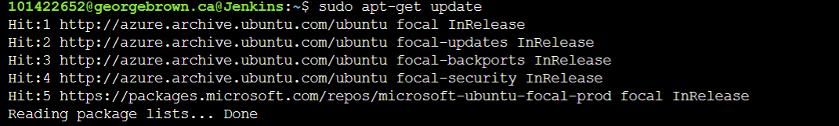

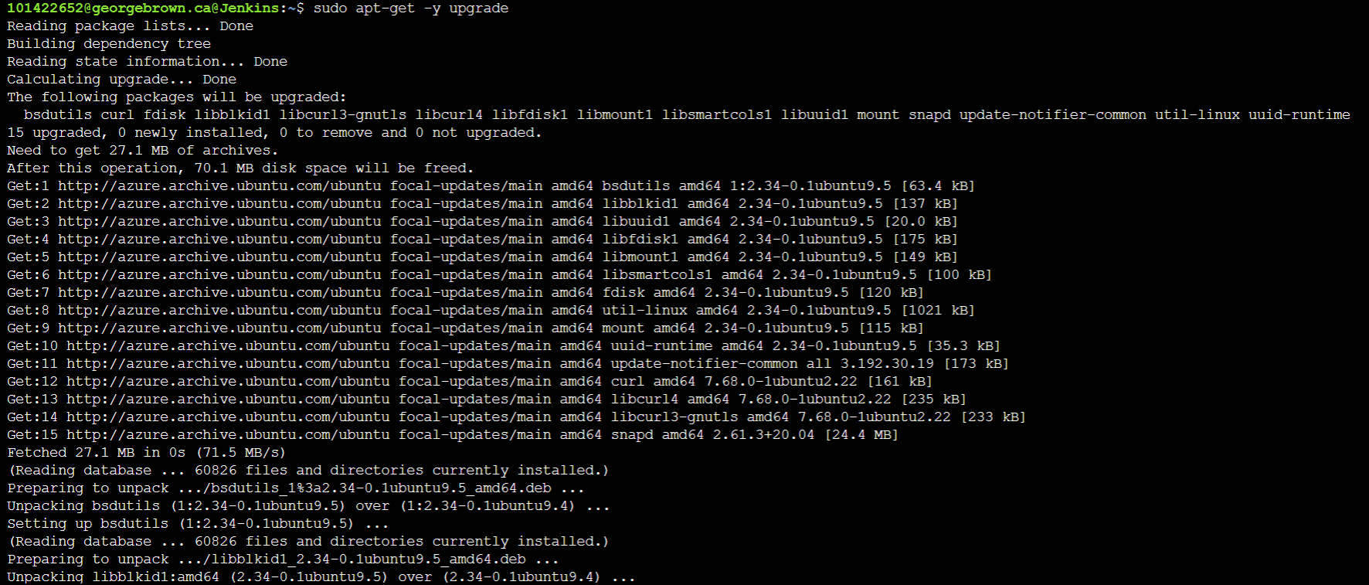

1. Java version



1. Downloading and Installing Jenkins

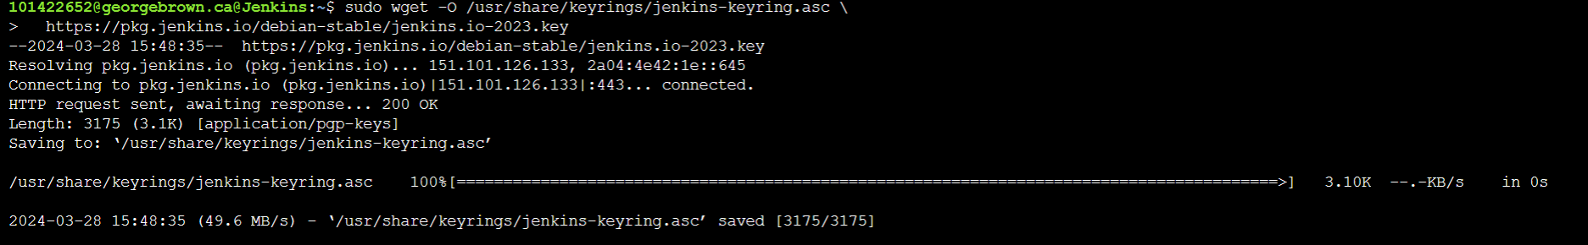



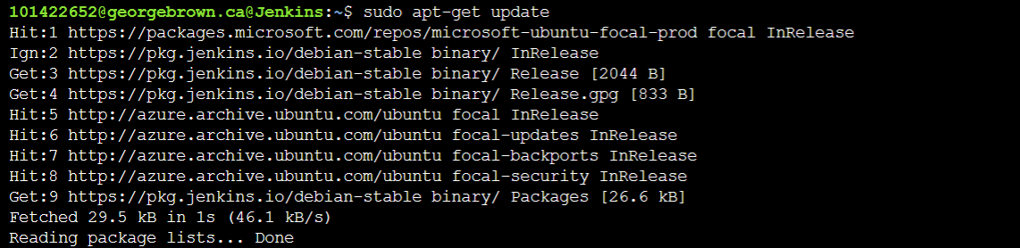

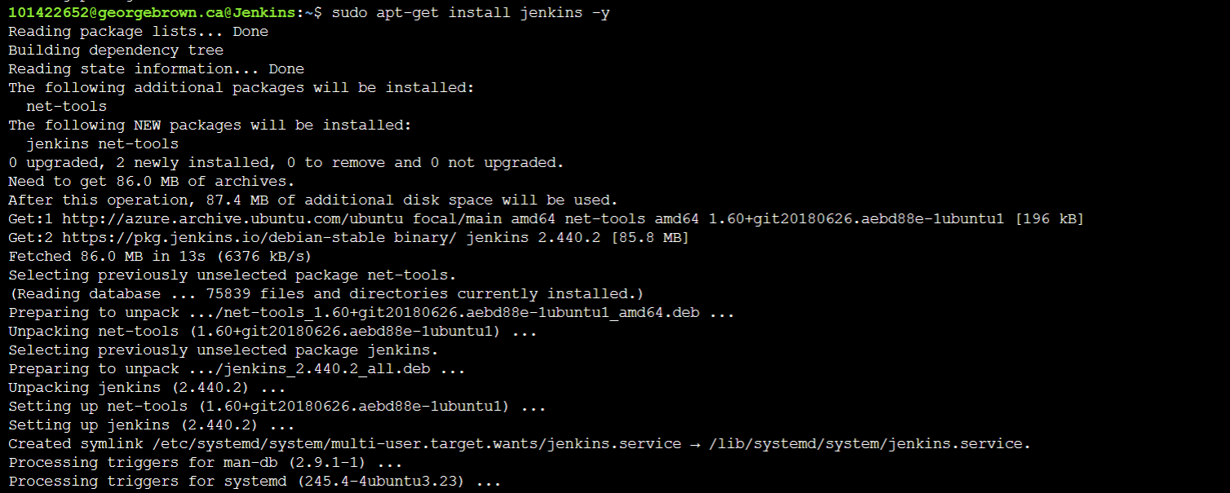

1. Start Jenkins Services

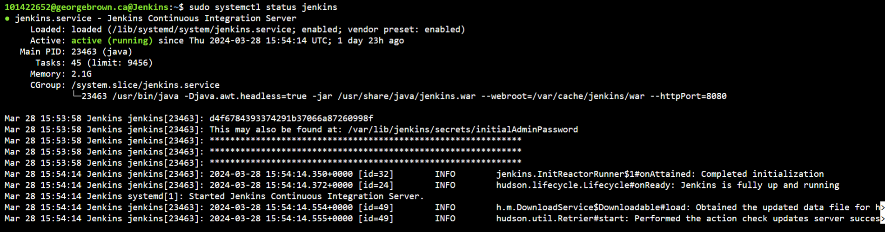

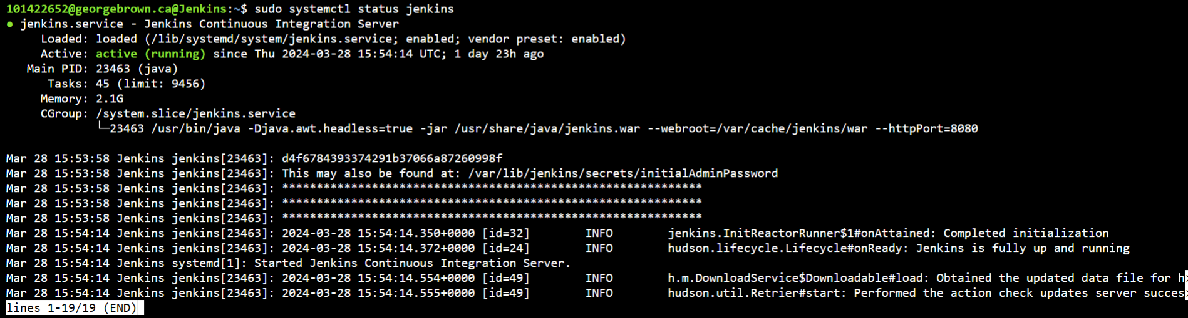

1. Installing docker

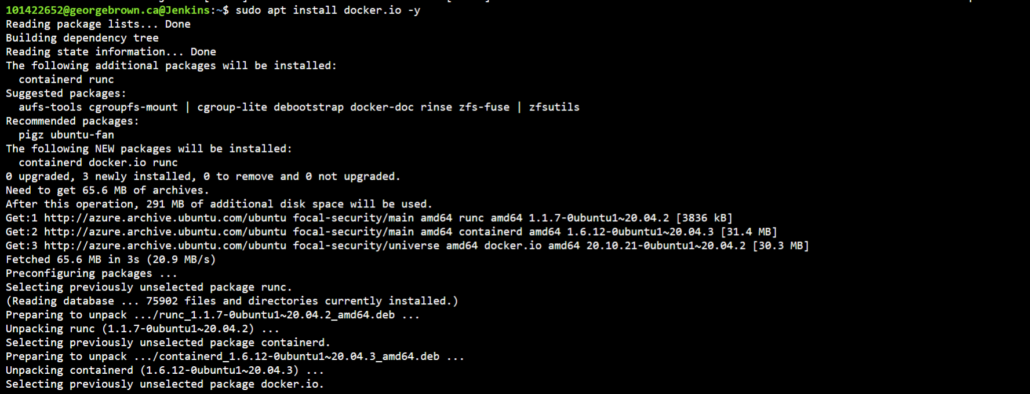

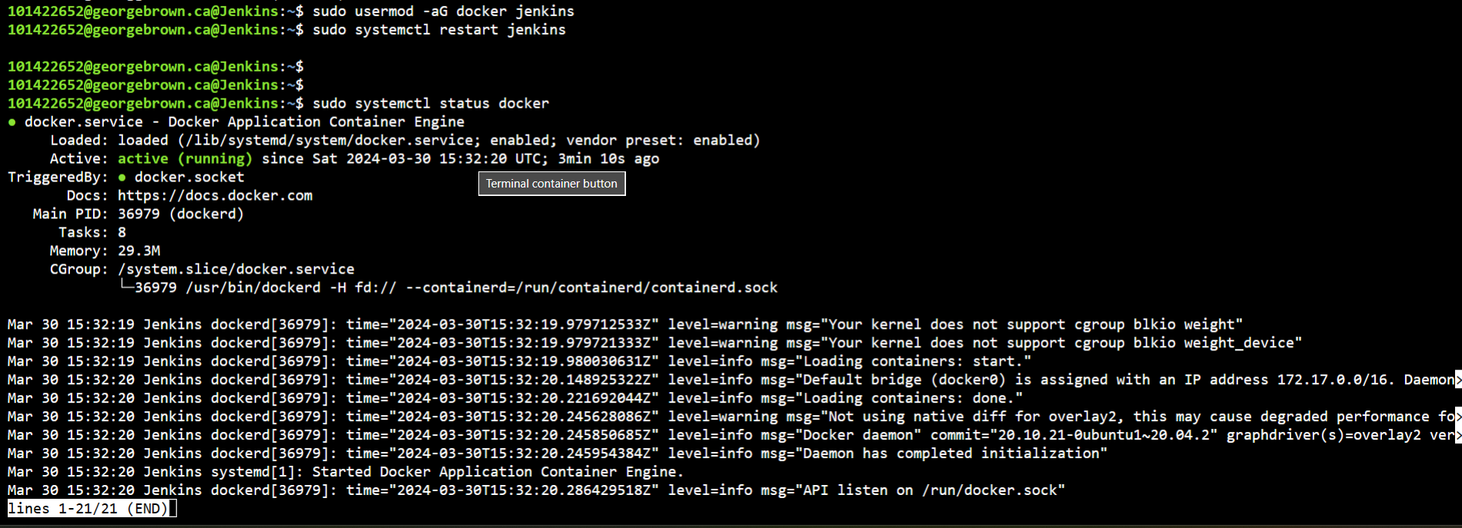

1. Docker version



1. Working with Docker Images

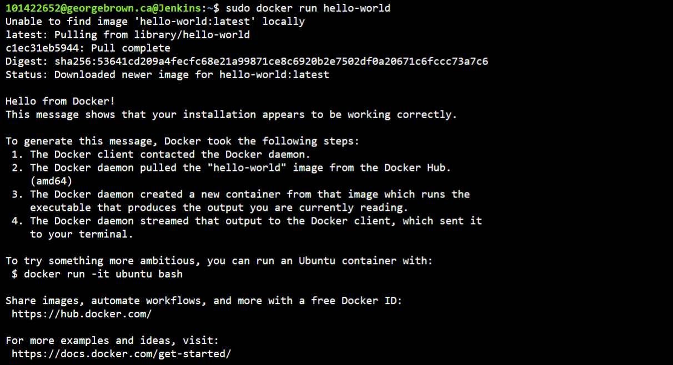

1. Install git

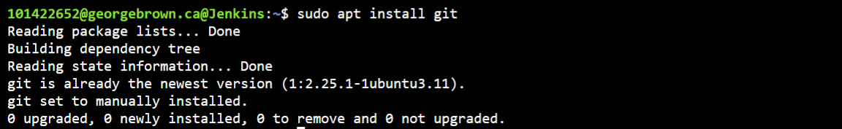

1. Version check

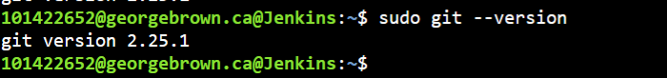

1. Git user setup and verify user setup

